|  |  |
| --- | --- |
| Semester | T.E. Semester V – Computer Engineering |
| Subject | Software Engineering |
| Subject Professor In-charge | Dr. Sachin Bojewar |
| Assisting Teachers | Prof. Sneha Annappanavar |
| Laboratory | M313B |

|  |  |
| --- | --- |
| Student Name | Deep Salunkhe |
| Roll Number | 21102A0014 |
| TE Division | A |

**Title: Data flow diagram**

**Explanation:**

A Data Flow Diagram (DFD) is a graphical representation of how data moves through a system. It is a modeling technique that illustrates the flow of data within a system, showing how inputs are transformed into outputs through processes.

Here are the key components and symbols used in a Data Flow Diagram:

1. Processes (Rectangles): Processes represent activities or transformations that occur within the system. They take input data, perform some operation, and produce output data.

2. Data Flows (Arrows): Data flows represent the movement of data between processes, data stores, and external entities. Arrows indicate the direction of data movement.

3. Data Stores (Parallel Lines): Data stores represent repositories where data is stored for later use. They can be databases, files, or any other storage mechanism.

4. External Entities (Rectangles with Rounded Corners): External entities are sources or destinations of data that interact with the system but are outside of it. They can be users, other systems, or external organizations.

There are different levels of Data Flow Diagrams:

- Context Diagram: Provides an overview of the entire system, showing the external entities and the high-level flow of data between them.

- Level 0 Diagram: Decomposes the context diagram into major processes and data stores, showing the flow of data between them.

- Detailed Diagrams (Level 1, Level 2, etc.): Continue to decompose processes into sub-processes and add more detail to the data flows, providing a more granular view of the system.

DFDs are useful for:

- Understanding System Functionality: DFDs help stakeholders visualize how data moves through a system and how it is processed.

- Requirements Analysis: DFDs are used during the requirements analysis phase to understand user requirements and system behavior.

- System Design: DFDs can be used to design system architecture and specify the details of processes and data flows.

- Communication: DFDs provide a clear and concise way to communicate complex systems to both technical and non-technical stakeholders.

DFDs are a part of Structured Analysis and Design, a set of techniques used in software engineering for modeling, specifying, and visualizing systems.

**Implementation:**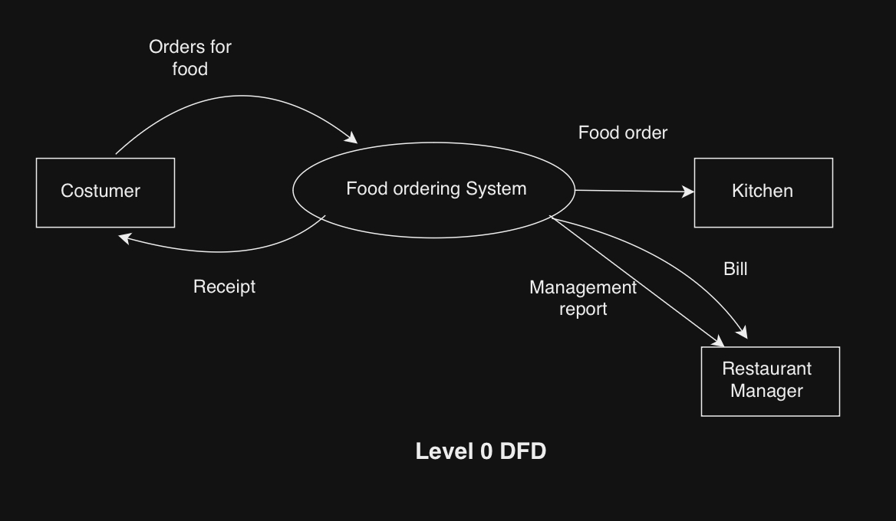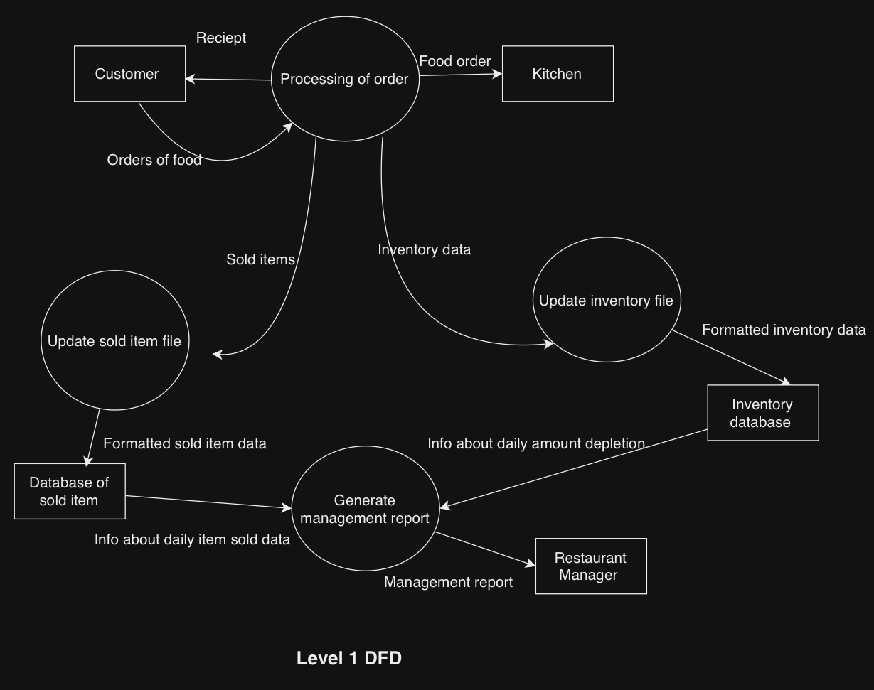

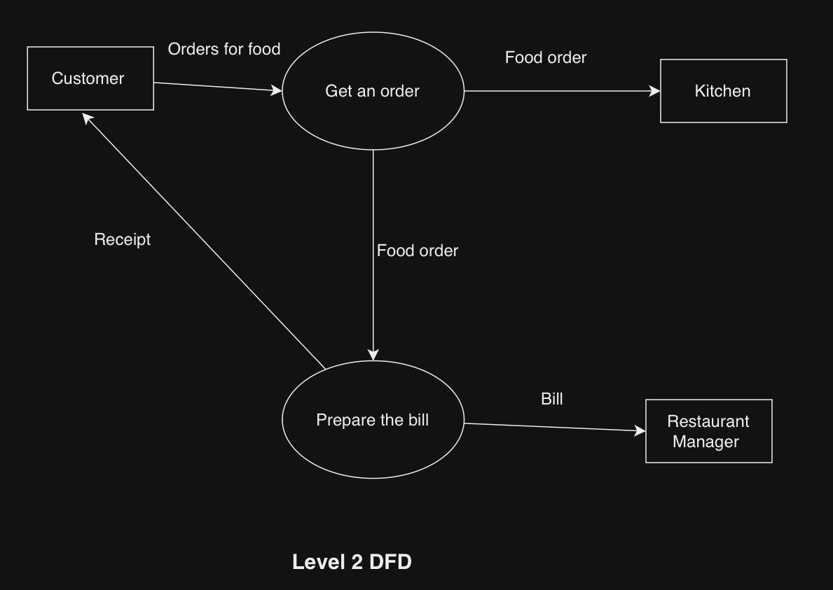

**Conclusion:**

Data Flow Diagrams (DFDs) are visual representations that illustrate how data moves through a system. They provide a clear and simple way to understand the flow of data from external sources through processes to data stores or external destinations. DFDs support requirements analysis, system design, and effective communication among stakeholders. Their hierarchical structure and ability to decompose complex systems make them valuable tools in systems analysis and design.